June 2022
Walker County Agriculture Update

Greetings from the Walker County, Texas A&M AgriLife Extension office!

Howdy!
Seems it is time for another newsletter. Time flies!

We got RAINED ON during the Plant Identification Workshop. Since that one was a little “damp” and some people decided to stay home, we are scheduling another session!! I will send out a notice when we have selected a viable date.

Featured Upcoming Events:

Rainwater Harvesting 101
June 1, 2022 (Wednesday)
1:00 PM to 4:00 PM
Walker County AgriLife Extension Service (102 Tam Road, Huntsville, TX 77320)
Cost: FREE!!
Registration online at: https://www.eventbrite.com/e/rainwater-harvesting-101-tickets-307174094987
Event presented by Bluebonnet Groundwater Conservation District (&) Texas Water Resources Institute of Texas A&M AgriLife Extension

Join us to learn the basics of rainwater harvesting! Field experts will provide you with the information and hands-on experience needed to design and implement a rainwater collection system of your own.

Attendees will learn the basics of Rainwater Harvesting including a brief overview of how to design a system, components of a collection system, different applications for use, calculating storage needs, benefits of rainwater for use as an alternative water source, and conservation tips to make every drop count.

Rainwater Harvesting 101 is sponsored by Bluebonnet Groundwater Conservation District in conjunction with Texas Water Resources Institute of Texas A&M AgriLife Extension Service. The program speaker will be Specialist John Smith, out of the Texas A&M Dept. of Soil and Crop Sciences. This program is free to attend, with refreshments and all materials provided.

2022 Walker County Farmers Market Grand Opening
Date: June 4, 2022 (Saturday)
Regular dates through the season are Wednesday and Saturday mornings
Time: 8:00 AM until Sell Out
Location: West Hill Mall parking lot (Highway 30 W, Huntsville, TX)

It is FRESH PRODUCE season!!!

Local producers of high-quality produce and handmade products will be on site the annual Grand Opening of our Farmers Market. Come by and enjoy the best agricultural products our county has to offer. Items include vegetables, fruit, canned goods, meat products, baked & sewed materials plus many more specialty items! The Walker County Farmers Market is held in the parking lot of West Hill Mall beside Highway 30. The market will be open on Wednesday and Saturday mornings as long as locally produced items are available.

Homemade Huntsville (“Hands On” Workshops)
Texas A&M AgriLife, Walker County
Remaining Events April through November 2022
Workshops will be held at the Walker Co Storm Shelter
Registration Fee includes ALL supplies, refreshments, and take-home items: $30.00 per person for any one session.
JUNE Registration Link: Homemade Huntsville - June 2, 2022 Pickles & Relish Workshop Tickets, Thu, Jun 2, 2022 at 10:00 AM | Eventbrite

Walker County, Family & Consumer Health Agent, Meredith Cryer has a scheduled educational series active and “on the front burner” with eight additional upcoming workshops scheduled April through November in our Homemade Huntsville series. These events are posted under the preceding link providing specific subjects, dates, times, registration, and other information. Be sure to scroll down the page to Homemade Huntsville (the Preserving the Harvest sessions at the top of page are SOLD OUT).
- June 2 - Pickles & Relish
- July 7 – Fermentation
- August 4 – Pressure Cooking
- September 1 – Breads
- October 6 – Pies & Fillings
- November 17 – Holiday Treats

Agriculture Management Series: Timber Harvest & Timber Theft Prevention
Date: June 8, 2022 (Wednesday)
Time: 6:30 PM until 8:00 PM
Location: Walker County AgriLife Extension office (102 Tam Road, Huntsville, TX)
Cost: $10.00 per participant
Registration: Requested online before program Agriculture Management Series: Timber Harvest & Timber Theft Prevention Tickets, Wed, Jun 8, 2022 at 6:30 PM | Eventbrite
For additional information contact: Reggie Lepley, CEA (936) 435-2426 or r-lepley@tamu.edu or Ben Plunkett, District Forester -TFS (936) 295-5688 bplunkett@tfs.tamu.edu

This forestry topic session will feature methods, procedures, and other great things to know when preparing to harvest your timber stands. Ben Plunkett will discuss the important items each landowner needs to be aware of when planning a timber harvest. Josh Mizrany with the Texas Forest Service, Law Enforcement Division will provide an updated outline of methods and options you have to prevent timber theft. Harvesting and theft prevention are areas which all forest landowners should be current on the best options available. Join us to learn more and protect your investment!

Area and/or Online Upcoming Events:

Houston County 2022 Landowners Program Series
Date: Several (see below)
Time: 9:00 AM to 2:00 PM CST
Location: Houston County (Crockett)
Registration: online at https://tamuagrilifeextension.wufoo.com/forms/2022-landowner-program-series/
Cost: $45.00 per person / $65.00 per couple (+ $10.00 late fee after May 27)
Lunch will be own you own. Each class will require a minimum of 10 registrants to be held.
For additional information contact: Jo Smith jo.smith@agnet.tamu.edu (or) 936-544-7502

June 3, Forage Seminar. Topics include Weed ID, Soil Analysis, Soil Fertility, Hay Baling and Storage Spraying vs. Mowing, Sprayer calibration.
July 1, Beef Seminar. Topics include “Beef 101”, Beef Quality Assurance, Herd Health Program, Bull Selection, Breeding Soundness Exam, and Marketing. This session will include a trip to East Texas Livestock for hands on experience.
August 5, General Seminar. Topics include Food Plots for Wildlife; Pond Management, Aquatic Weed ID, Pond Water Testing, Hog Control, Property Tax Valuations/Exemptions as it relates to Agriculture,
Natural Resource Conservation Service Programs.
September 9, 5 Hour Pesticide CEU Recertification & Pesticide License Training Class (Cost & Registration is separate)
October 28, Cow Country Congress (Cost & Registration is separate)

Grimes County 2022 Landowners Program Series
Date: Several (see below)
Time: 6:00 PM to 7:30 PM
Location: Grimes County Fairgrounds (5220 FM 3455, Navasota, TX 77868)
Registration: contact Kyla Moeller (979) 873-3907 or kyla.gladson@ag.tamu.edu
Cost: $20.00 per person (meal included with program)

Common tree issues give homeowners lots of items to think about. Potential diseases, insects, problems caused by weather and (even) the owners, are all on the discussion table. This class will explore many of the topics which you may have wondered about. The class will be presented by Connor Murnane and Ben Plunkett with Texas A&M Forest Service.

Algal Blooms (webinar)
Date: June 21, 2022
6:00 PM CST
Location: online
Cost: $35.00

Registration: https://tamu.estore.flywire.com/products/algal-blooms-june-21-24927
For additional information contact Brittany Chesser at brittany.chesser@tamu.edu

Join us for a how-to educational program on all thing’s algae and cyanobacteria. We will cover how to identify the main groups of algae, from micro to macro forms, as well as cyanobacteria and other harmful algal blooms. Once identified, we will briefly discuss their biology and how that plays a role in the pond's ecosystem and management. Specific management strategies, including mechanical, biological, and chemical options, when applicable, will be covered for each grouping. Finally, we will discuss the importance of correctly calculating copper by using the label for effective control and treatment timing.

(Registration is Open) Texas A&M Beef Cattle Short Course
Date: August 1-3, 2022
All Day/each day
Location: On campus TX A&M University (or) online option
Cost: $240.00 per participant in person (or) $160.00 per participant online before July 27 (prices go up to $280 and $210, respectively, after July 27)

Registration: www.beefcattleshortcourse.com
For additional information call 979-845-6931
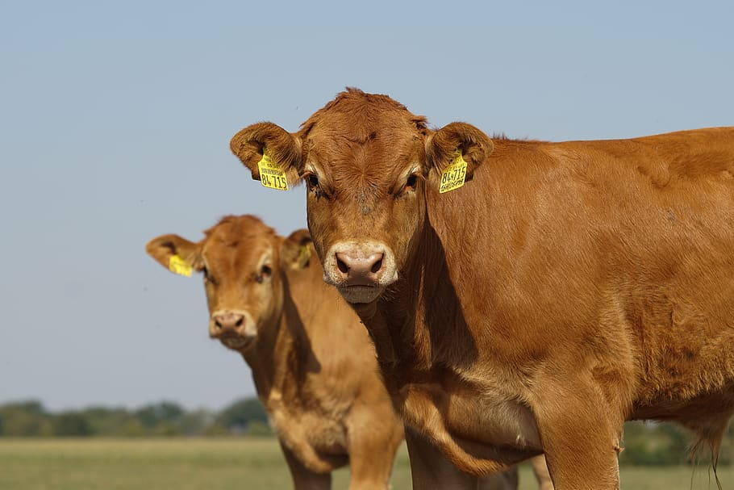
The Texas A&M Beef Cattle Short Course has a rich tradition and historical place in the programs emanating from the Department of Animal Science at Texas A&M University. Dating as far back as 1942, Professor John K Riggs started the first in a series of Beef Cattle Short Courses held on the campus of Texas A&M College to discuss the results of beef cattle research from the Texas Agricultural Experiment Station with Texas beef producers. This historical beginning and purpose are still the standard today for the Beef Cattle Short Course held at Texas A&M University.

Today the highly respected TAM Beef Cattle Short Course is nationally and internationally recognized as the largest attended beef cattle educational program of its type in the world. It has gained the respect from organizations, associations, Land Grant universities and agencies alike as the focal point for beef cattle educational information. The Cattleman’s College features more than 20 concurrent sessions. Topics include animal health, nutrition, reproduction, breeding, genetics, selection, research, marketing, and handling. Management sessions will cover business, forage, range, and purebred cattle. Topics such as landowner issues and fence building will be featured at this BCSC. Sessions are designed for everyone, from the newest member of the industry to the most seasoned producer. A number of pesticide CEUs and veterinarian CECs are available to attendees. Additionally, over 150 agriculture related businesses and trade show exhibitors annually attend the course and attest to the fact that it is the most highly attended activity of its kind anywhere in the United States. Annually over 1,700 participants attend the Beef Cattle Short Course to gain valuable knowledge about beef cattle production.

Additional Items and Information of Note:

Your Input is needed!
Take The Texas Beef Producer Feedback Survey Today.

The Texas Beef Councils goal is to continue providing you with relevant information about the beef industry. We want to ensure our communications are meeting your needs, especially given the always-changing cattle industry and market conditions.

Please take a few minutes to complete this survey to help us understand your priorities and preferences for communications about our industry and the Texas Beef Checkoff. Which forces are impacting your operation the most? Which topics are of greatest interest and importance to you? What would you like to see more of and less of? Your responses will have a direct impact on the content we provide in the future.

In appreciation for your input, you will be entered into a drawing for a chance to win a Beef Loving Texans merchandise bundle or grilling basket from Texas Beef Council. Be sure to complete the survey by May 31, 2022, to be eligible for the drawing. See Rules for complete details.

Thanks for your feedback and happy Beef Month!

Provisions from the American Disability Act will be considered when planning educational programs and activities. Please notify the Walker County Extension Office if you plan on attending an Extension Educational program and need specialized services. Notification of at least three to five days in advance is needed, so that we may have ample time to acquire resources needed to meet your needs.
Educational programs of the Texas A&M AgriLife Extension Service are open to all people without regard to race, color, religion, sex, national origin, age, disability, genetic information, or veteran status. The Texas A&M University System, U.S. Department of Agriculture, and the County Commissioners Courts of Texas Cooperating

If you have questions or would like more information regarding Extension Educational Programs, call us at (936) 435-2426.
Reggie Lepley
Reggie Lepley,
County Extension Agent – Agriculture & Natural Resources
Walker County
(936) 435-2426
r-lepley@tamu.edu

